Below is a brief guide for obtaining permissions via the Copyright Clearance Center. Their website is marketplace.copyright.com. If you have any questions, please reach out to Samantha Grossman (our permissions coordinator) at samantha.grossman@guilford.com.

Step one: I need permission to use copyrighted content in: Select “Publications”
Step two: I represent or am a… Select “Publishing company or agency”, then hit Next.
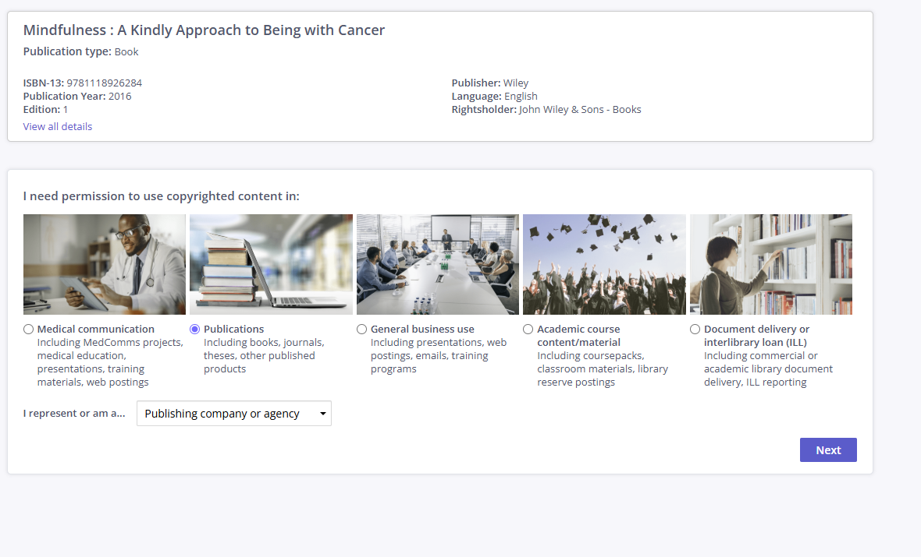

Step three: Type of Use (TOU): Select “Republish in a book”. Fill out the following drop down as specified by your editorial contact. Please note that the information requested can vary from publisher to publisher, so the drop down menu you see may differ from the one shown here.
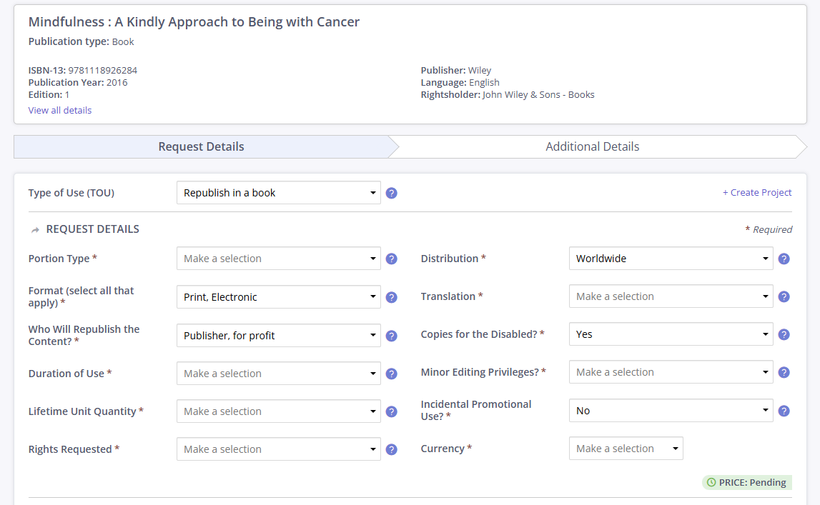
Always select “Print and Electronic” for Format, “Publisher for Profit” for Who Will Republish the Content, “Worldwide” for Distribution, “Yes” for Copies for the Disabled, and “No” for Incidental Promotional Use.

For Duration of Use, we prefer “Life of current and all future editions”, but this may increase the fee. If necessary, we can accept “Life of current edition”.

You’ll then fill out the details of your book.

Below is another example of what the CCC form can look like.
